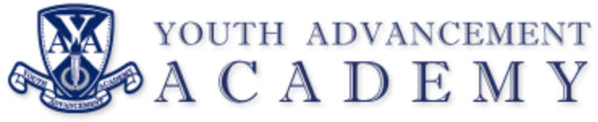

REGULAR BOARD MEETING
Chime School
Kalamazoo, MI 49009
Tuesday, November 14, 2023
5:30 PM

REGULAR MEETING AGENDA

- Call to Order Regular Meeting
  - Meeting called to order at 5:33 p.m.

- Pledge of Allegiance

- Roll Call
  - Members present: Saunders, Brennan, Mixis, Mora, Raines
  - Others present: Dr. Jeff Hamlin (EPI), Mr. Tom Zhart (KRESA), Mr. Angela Rudolph (EPI), Mr. Brett Luplow (Financial Auditor)

- Approval of Agenda
  - Motion made by Brennan, seconded by Saunders, voice vote unanimously approved

- Call to the Audience – Audience may address the Board (five minute maximum)

- Approval of Minutes
October 10, 2023, Regular Meeting
  - Motion made by Saunders, seconded by Brennan, voice vote unanimously approved

- Communications
Director’s Report – Ms. Stacey Smith
  - Student of the Month: K. Spurlock
  - Staff Member of the Month: Ms. Carroll
  - Team attended Alternative Education Symposium November 3rd; staff will be hosting Thanksgiving dinner for students.
  - Current enrollment at 35 students from Kalamazoo Public Schools, Portage, and Vicksburg
  - New security staff started and working with students as behavioral coach.
  - Thanksgiving break begins November 22nd. Team will have holiday get together in December.
  - Portables on the property are currently being dismantled and students will be virtual on days of demolition.

- Regular Agenda
- Financial Report: Dr. Hamlin
  - Not a lot going on with the finances given state aid is pending to drop in the upcoming days. Incoming funds from billing of districts comes later in the year and the budget will look different as the months go along. Billing for the school year to districts to go out in May with UIC codes to assist in billing processing. Budget amendments are expected in January.
- Auditor’s Report: Brett Luplow
  - Second year of audit by same firm. Solid year from a financial perspective. Purpose of the audit was explained by Mr. Luplow. Opinion of the audit was unmodified and found clean reporting. No significant auditing adjustments or disagreement with management. Mr. Luplow explained the findings from the audit to the board and provided responses to questions.
- School Facilities Update: Todd Mora
  - Mr. Mora provided an update on the recent developments related to the finding a new location. The recent conversations have moved the decision in a positive direction.
- Fall 2023 Board Policy Updates: 1st Reading
  - Board policy updates for Fall 2023 have been provided by NCSI. Updates can be viewed for review on the school’s website.
- ACTION: Board Attorney Attendance at Meetings
  - Conversation related to the budget and board needs related to the board attorney attending monthly board meetings.
  - Board decision is to have legal counsel present on a case-by-case basis and attendance may be requested by any board member as needed.

- Adjournment
  - Meeting adjourned at 6:28 p.m.

Next Meeting: December 12, 2023 (Chime School)

